**Prerequisites**

|  |  |
| --- | --- |
| Date | 17 November 2022 |
| Team ID | PNT2022TMID48329 |
| Project Name | Project – Early Detection of Chronic Kidney Disease using Machine Learning |

Prerequisites:

To complete the project we have used the following software and packages,

# Anaconda Navigator:

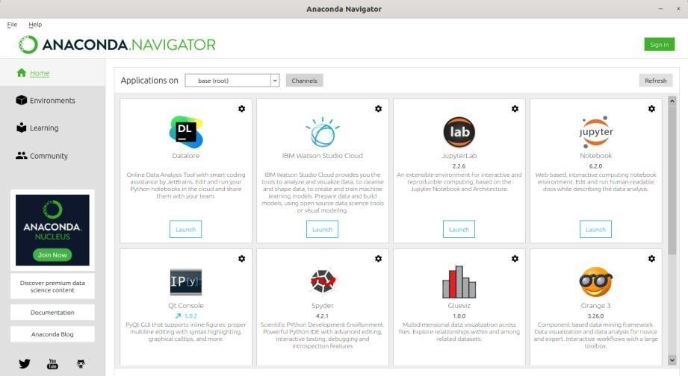

* Anaconda Navigator is a desktop graphical user interface (GUI) included in Anaconda Distribution that allows you to launch applications and manage conda packages, environments, and channels without using command line interface (CLI) commands.
* Navigator can search for packages on Anaconda.org or in a local Anaconda Repository.
* It is available for Windows, macOS, and Linux.
* Installation steps,

1. Visit Anaconda.com/downloads.
2. Select Windows.
3. Download the .exe installer.
4. Open and run the .exe installer.
5. Open the Anaconda Prompt and run some Python code

# Jupyter Notebook:

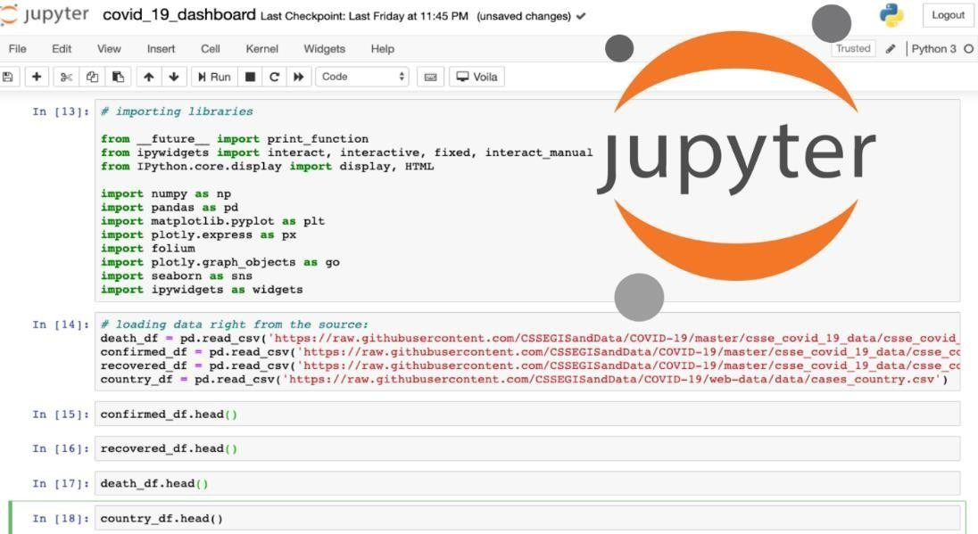

* The Jupyter Notebook is the original web application for creating and sharing computational documents. It offers a simple, streamlined, document-centric experience.
* Installation steps,

1. Download Anaconda. We recommend downloading Anaconda's latest Python 3 version (currently Python 3.9).
2. Install the version of Anaconda which you downloaded, following the instructions on the download page.

**To build Machine learning models we require the following packages:**

# Sklearn:

Scikit-learn is a library in Python that provides many unsupervised and supervised learning algorithms.

# NumPy:

NumPy is a Python package that stands for 'Numerical Python'. It is the core library for scientific computing, which contains a powerful n-dimensional array object

**“pip install numpy”**

# Pandas:

pandas is a fast, powerful, flexible, and easy to use open source data analysis and manipulation tool,built on top of the Python programming language.

**“pip install pandas”**

# Matplotlib:

It provides an object-oriented API for embedding plots into applications using general-purpose GUI toolkits.

**“pip install matplotlib”**

# Flask:

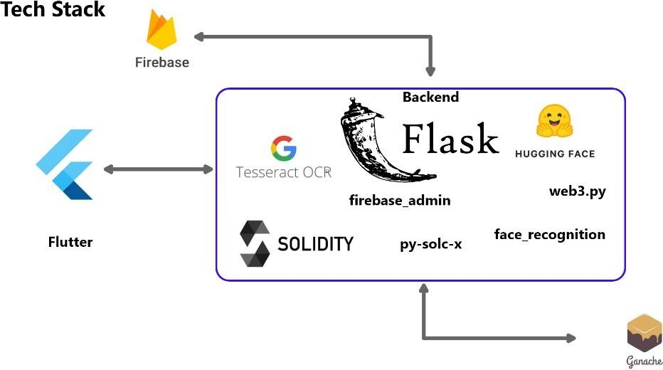

* Flask is a web application framework written in Python
* Flask is considered more [Pythonic](http://blog.startifact.com/posts/older/what-is-pythonic.html) than the [Django](https://www.fullstackpython.com/django.html) web framework because in common situations the equivalent Flask web application is more explicit.
* Flask is also easy to get started with as a beginner because there is little boilerplate code for getting a simple app up and running.

**“pip install Flask”**